5 Break

Workshop #5

Flutter Developer Bootcamp

# **Purpose**

This workshop demonstrates how to use a break statement in the code, Which is used to immediately stop the for loop when the variable i reaches 5, preventing further iterations.

**Problem**

In the given workshop The provided Dart code snippet features a for loop that iterates from 0 to 15. During each iteration, it prints the current value of i to the console. However, when the loop reaches i = 5, a conditional check (if (i == 5)) triggers a break statement. This causes the loop to terminate immediately after printing 'breaked in 5'. As a result, any subsequent iterations from 6 to 15 are skipped entirely. This example effectively demonstrates the break statement's role in controlling program flow within loops, enabling early termination based on specific conditions.You need to print ‘breaked in 4’ , make break statement in number 4.

**How to Solve**

1. Checkout the workshop from Git Repo:

git clone -b <user-branch> <repo-URL>

1. Open the root folder inside VS Code
2. Open the root folder in terminal
3. Run the command dart run filename.dart
4. The Dart code snippet starts with a for loop iterating from 0 to 15.
5. During each iteration, it prints the current value of i to the console (print(i);).
6. When i equals 4 (if (i == 4)), the code prints 'breaked in 4'.
7. Immediately after printing, the break; statement is encountered.
8. This break; statement causes the loop to terminate prematurely.
9. As a result, any subsequent iterations from 5 to 15 are skipped entirely.
10. Go To File: <specific-file--method> à <method-name>, implement your logic.

**You will Achieve**

When you complete this workshop you will learn the following:

**Methods and Functions Used:**

* **Main Function (main):**
* Entry point of Dart programs where execution begins.
* Uses the main function signature: void main(List<String> args).
* **For Loop:**
* Iterates over a sequence of numbers using for (int i = 0; i <= 15; i++).
* Starts with i initialized to 0, increments i by 1 after each iteration, and continues until i is 15 (i <= 15).
* **Conditional Statement (if):**
* Checks a condition within the loop using if (i == 4).
* Executes a block of code if i equals 4.
* **Print Function (print):**
* Outputs the current value of i during each iteration of the loop (print(i);).
* Displays the message 'breaked in 4' when the condition i == 4 is met (print('breaked in $i');).
* **Break Statement:**
* Used to terminate the loop immediately upon meeting the condition i == 4.
* Stops further execution of the loop and exits it prematurely (break;)**.**

# **Screenshots**

## **Before implementation (without making break in 4)**

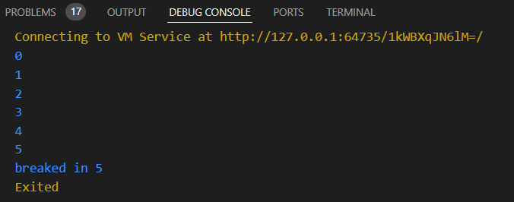

## **After implementation (with making break in 5)**

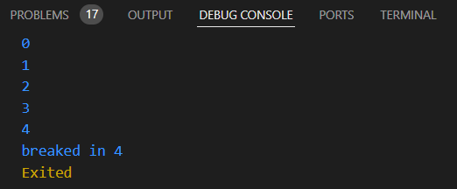

# **How to submit your workshop**

Push your project back to the same git branch using command:

<command name>

# **Happy Coding!**